

SIMATS ENGINEERING

Saveetha Institute of Medical and Technical Sciences
Chennai- 602105

Student Name: G. Aswartha Manidheep Reg. No.:192425089
Course Code: DSA0306 Slot: C
Course Name: NATURAL LANGUAGE PROCESSING
Course Faculty: Kumaragurubaran T
Project Title: DocInsight AI: An Intelligent Document Analysis and Question Answering System
Module Photographs: (3 photographs –Module Photo, Individual student contribution module work in the project and presentation image)
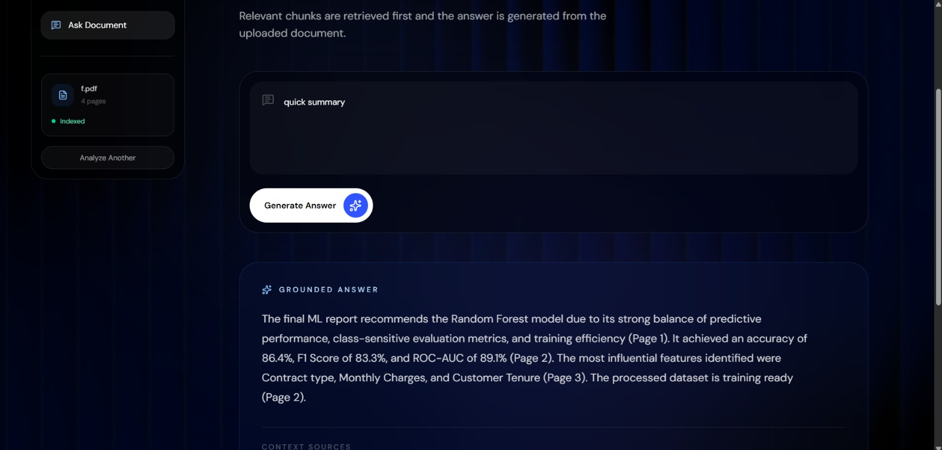
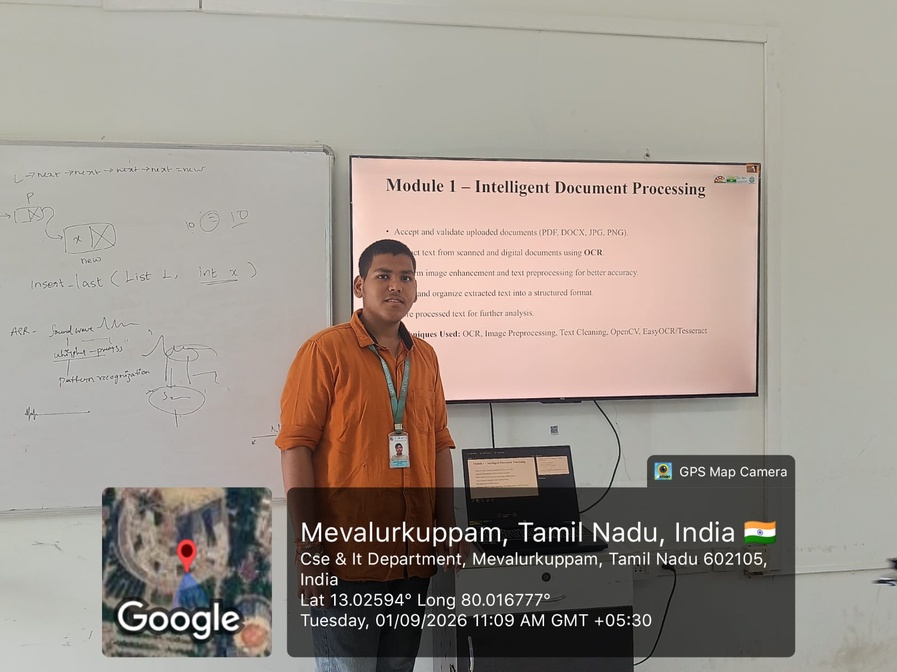

Project Description:

DocInsight AI uses intelligent document processing to upload, read, extract, and organize information from different types of documents. The module processes text from PDFs, reports, notes, and other document formats using AI and NLP techniques. It identifies relevant content, removes unnecessary information, and prepares the extracted data for further analysis. This reduces the need for manual document processing and saves time when handling large volumes of information. The processed content serves as the foundation for insight generation, semantic search, and AI-powered question answering. The system can be useful for students, researchers, educators, and professionals for quickly accessing information from large documents. Overall, DocInsight AI aims to provide an efficient, intelligent, and user-friendly solution for document analysis and knowledge retrieval.

Student Signature Guide Signature

